|  |
| --- |
| ­­ |
| DBMS Lab Assignment-II |
|  |
|  |
| **B.Tech (Computer Engg) V Semester** |
| **SAURABH MEHTA**  **11CSS54** |

|  |
| --- |
|  |

**Q . Consider the following three tables:**

**Catalog ( bookid, pubid, title, author )**

**Publisher ( pubid, pubname, title, year )**

**Order ( bookid, type, author, price, quantity)**

**Order Table**

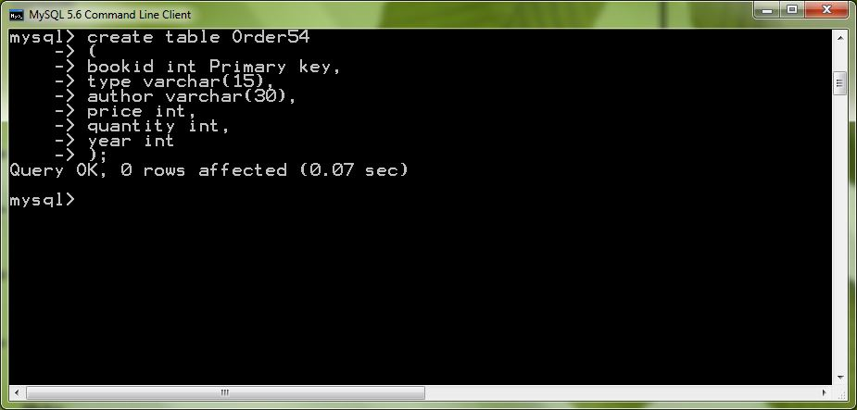

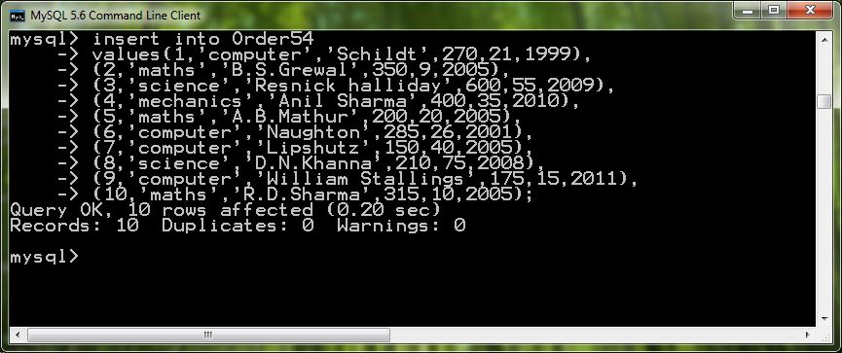

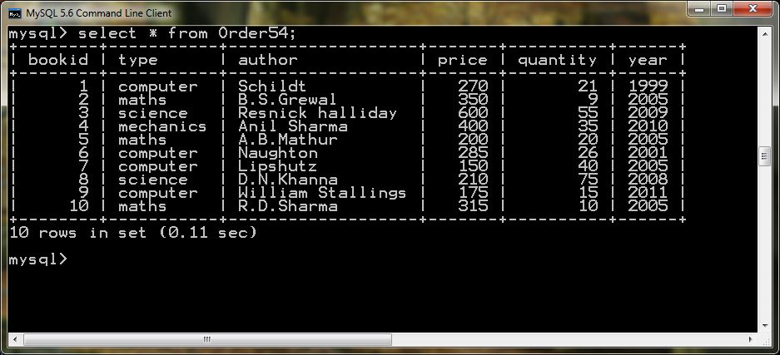

**Publisher Table**

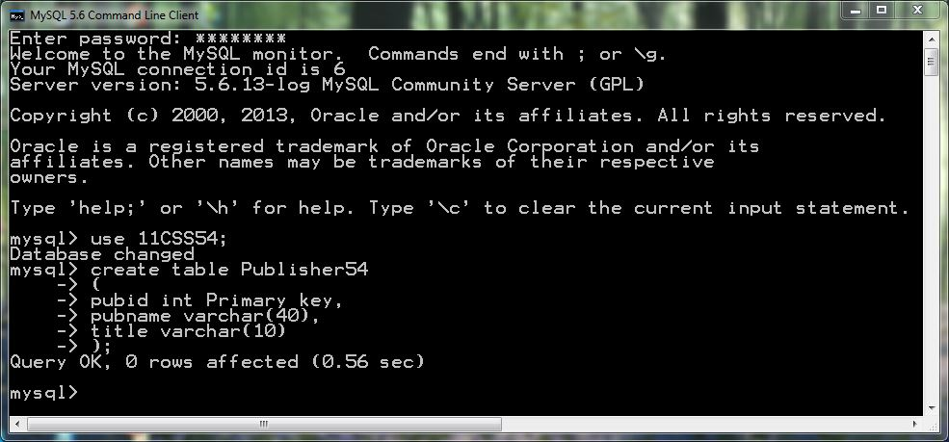

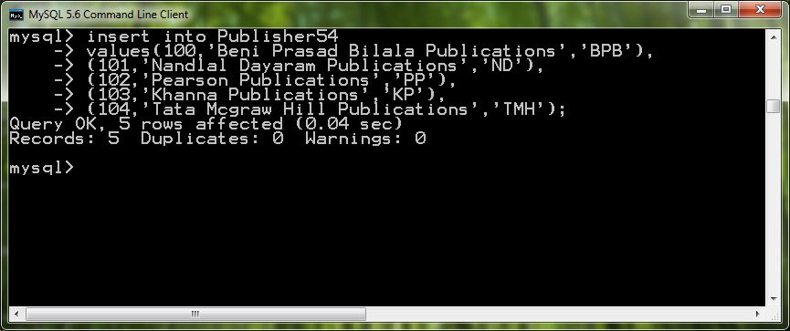

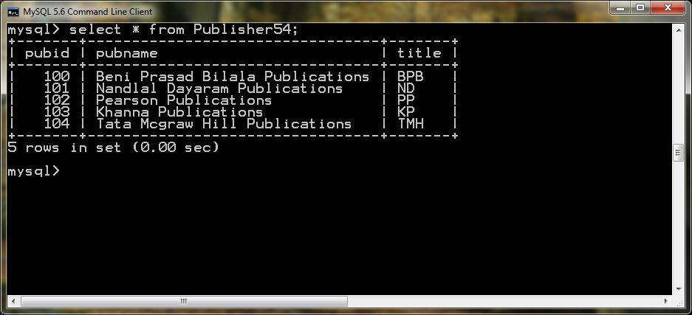

**Catalog Table**

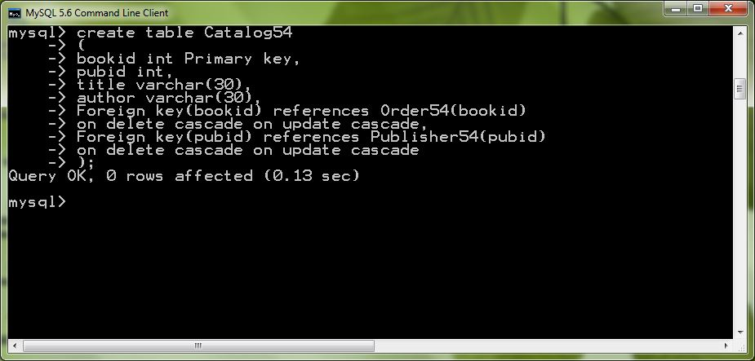

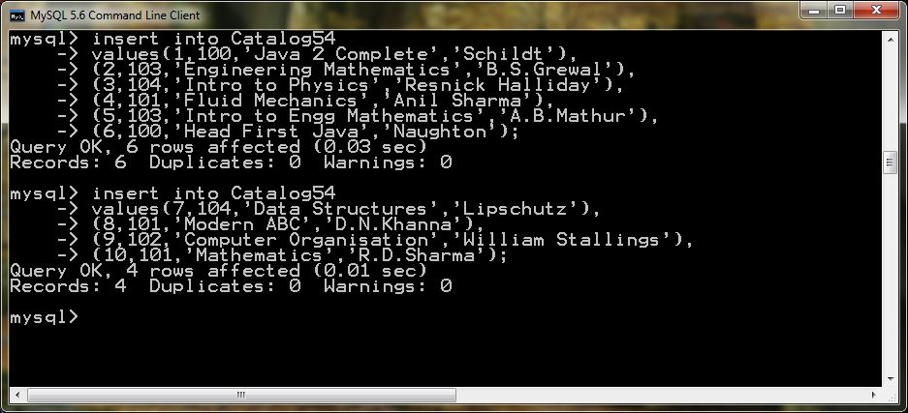

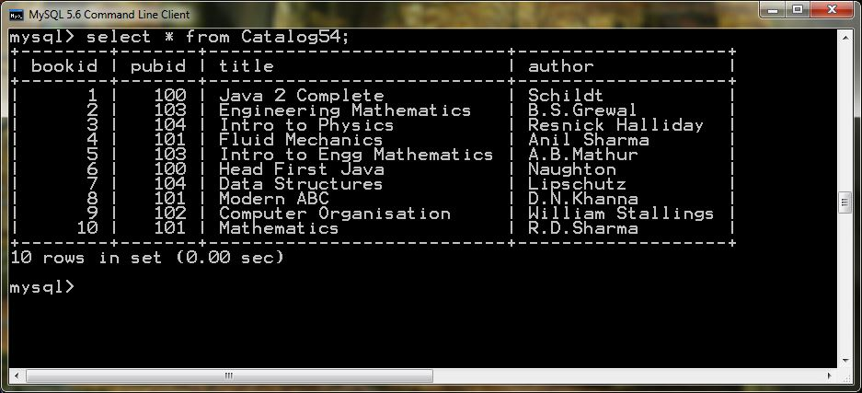

**Write equivalent SQL for the following query:-**

1. **Increase the price of all books of computer type by 15% published by BPB.**

Ans:- update Order54 o,Catalog54 c ,Publisher54 p set o.price=o.price+0.15*o.price

where o.bookid=c.bookid and c.pubid=p.pubid and p.title=’BPB’ and o.type=’computer’;

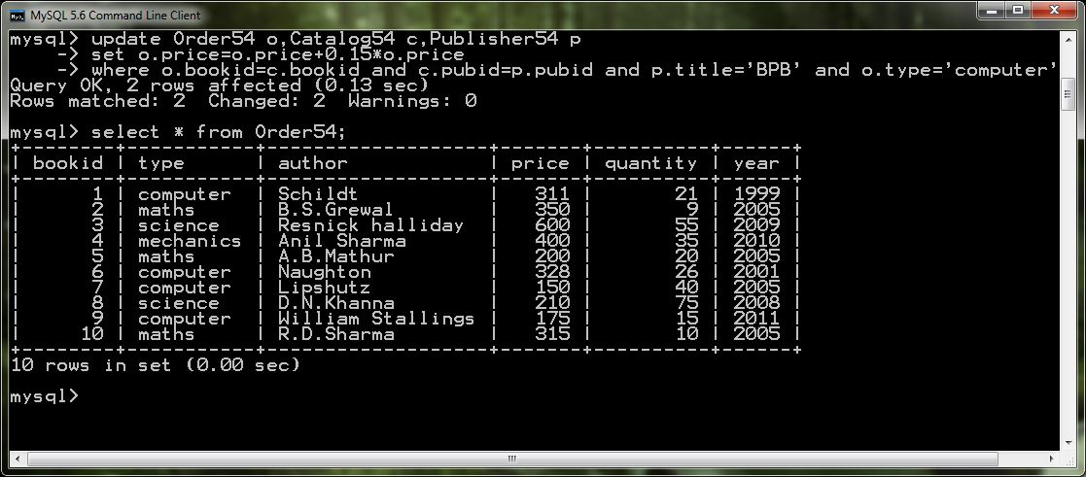

1. **Display the maximum price of books.**

Ans:- select distinct(max(price)) as max_price from Order54;

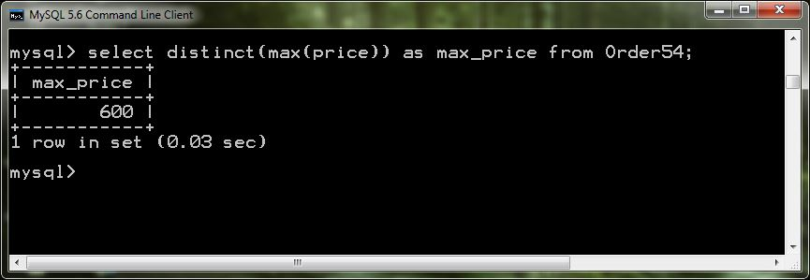

1. **Display the second highest price of books.**

Ans:- select distinct(max(price)) as 2ndmax_price from Order54 where price not in (select max(price) from order54);

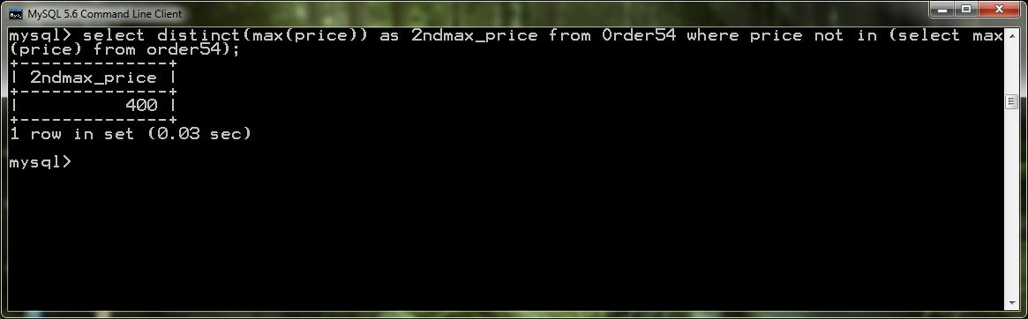

1. **Get the pubid, pubname of all the books whose quantity > 50.**

Ans:-select p.pubid,p.pubname,c.title,o.quantity from Publisher54 p , Order54 o

,Catalog54 c where p.pubid=c.pubid and c.bookid=o.bookid and o.quantity > 50;

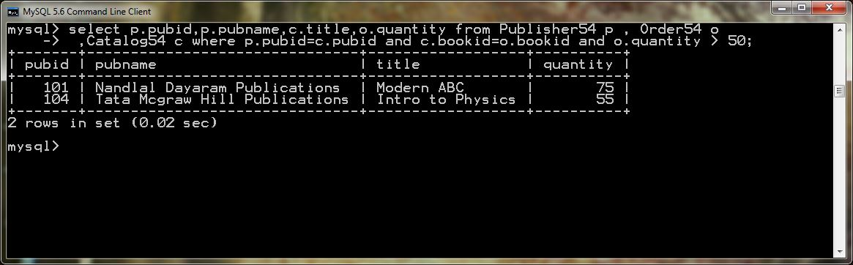

1. **Get total price of all the books published in year 2005.**

Ans:- select sum(price*quantity) as total_price from Order54 where year=2005;

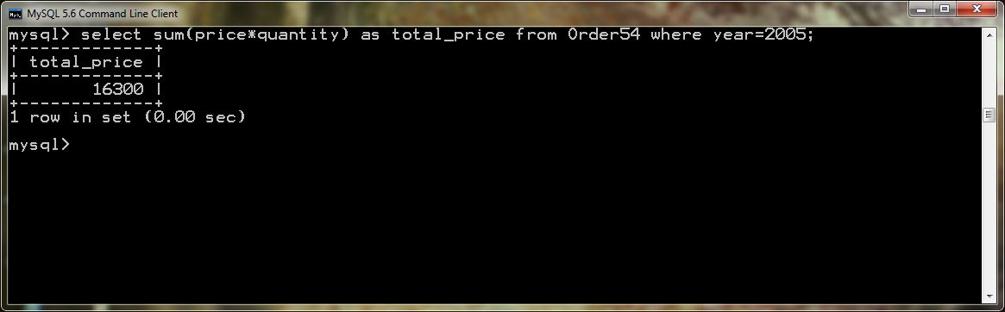

1. **Get the pubname, author of all the books.**

Ans:- select p.pubname,c.author,c.title from Publisher54 p,Catalog54 c where p.pubid=c.pubid;

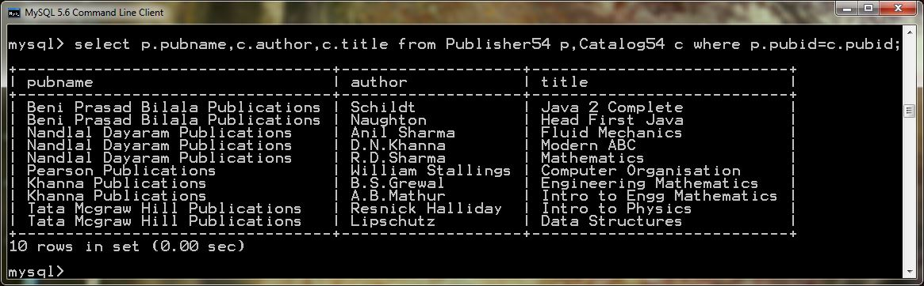

1. **Find name of all the author whose second character is ‘n’.**

Ans:- select author from Catalog54 where author like ‘ _n%’;

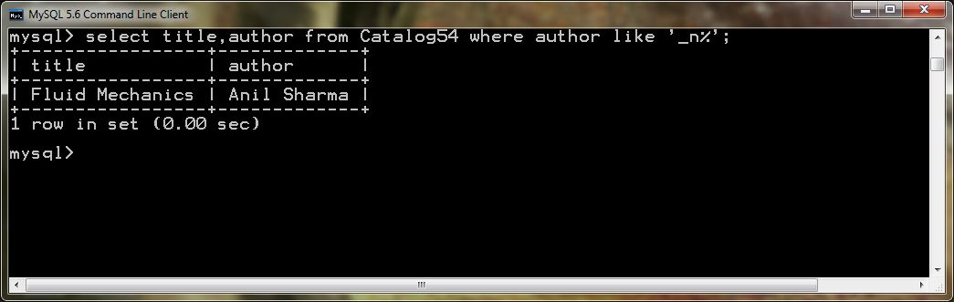

1. **Change year of publishing of all the books from 2005 to 2008 where quantity > 10.**

Ans:-update Order54 set year=2008 where year=2005 and quantity>10;

